**SALES AND INVENTORY MANAGEMENT SYSTEM FOR BABY PRODUCTS SHOP**

**CASE STUDY OF ZETECH UNIVERSITY**

**SYSTEM PROPOSAL BY**

**ABDALLAH JARED**

**DIT-01-8384/2020**

**A SYSTEM RESEARCH PROPOSAL WRITTEN IN PARTIAL FULFILMENT FOR THE AWARD OF A DIPLOMA IN INFORMATION TECHNOLOGY BY ZETECH UNIVERSITY.**

**JANUARY 2022**

**TABLE OF CONTENTS**

**DECLARATION** i

**ACKNOWLEDGEMENT** ii

**DEFINITION OF KEY TERMS** iii

**ABBREVIATIONS AND ACRONYMS** iv

**ABSTRACT** v

**LIST OF FIGURES** vi

**LIST OF TABLES** vii

**CHAPTER ONE: RESEARCH INTRODUCTION** 1

**1.1** **Executive Summary** 1

**1.2** **Research Objectives** 1

**1.2.1** **General Objective** 1

**1.2.2** **Specific Objectives** 1

**1.3** **Background Information** 1

**1.4** **Study Justification** 1

**1.5** **Study Limitation** 1

**1.6** **Problem Scope** 1

**CHAPTER TWO: LITERATURE REVIEW** 2

**2.1 Introduction** 2

**2.2 Global Review** 2

**2.3 Regional Review** 2

**2.4 Local Review** 2

**CHAPTER THREE: SYSTEM METHODOLOGY AND DATA COLLECTION** 3

**3.1 Introduction** 3

**3.2 System Requirements Specification** 3

**3.2.1 Functional Requirements** 3

**3.2.2 Non Functional Requirements** 3

**3.3. Design** 3

**3.3.1 Low Level Design** 3

**3.3.2 High Level Design** 3

**3.4 Implementation / Development** 3

**3.4.1 Language(s), Frameworks and Other Technical Requirements** 3

**3.4.2 Code Review Strategy** 3

**3.5 Testing** 4

**3.5.1 Functional Requirements Testing** 4

**3.5.2 Non-Functional Requirements Testing** 4

**3.6 Deployment** 4

**CHAPTER FOUR: CONCLUSION AND RECOMMENDATIONS** 5

**4.1 CONCLUSION** 5

**4.2 RECOMMENDATIONS** 5

**CHAPTER FIVE: REFERENCES AND APPENDICES** 6

**5.1 REFERENCES** 6

**5.2 APPENDIX I:** 6

**5.3 APPENDIX II:** 6

**5.4 APPENDIX III: GANTT CHART** 6

# **DECLARATION**

I Abdallah Jared that the project report on Sales And Inventory system For A Baby Shop product is based on my work carried out during course of our study under the supervision of lecturer Francis Mutuku. I assert the statements made and conclusions drawn are an outcome of my research work.

# **ACKNOWLEDGEMENT**

First of all, I would like to thank Allah for giving me the chance to be able to engage in this project. With HIM, all things are possible.

Secondly I would like to thank my lecturer Francis mutuku, he has been a great help in providing guidance and direction to where this project should lead while giving valuable comments on work done.

# **DEFINITION OF KEY TERMS**

Inventory management: refers to the process of ordering ,using and selling a company’s inventory.

Mysql: is a relational database management system based on sql.

# **ABBREVIATIONS AND ACRONYMS**

Mysql: structured query language

Html: hypertext markup language

Php: hypertext preprocessor

# **ABSTRACT**

The baby shop business system is to maximize profit from customer satisfaction and loyalty towards the baby shop system by providing more personalize service for the customer. However , business also easy to lose its possible customer if they don’t have sufficient stock in the store. Thus in this paper the developer had identified problem related with inventory that exist in eastlegh baby shop. The major problem is that they do not have proper inventory control system in guiding and managing their sale and inventory level of their baby products store.

By proposing sale and Inventory management system to the store as the replacement of old manual ways, the project aims in providing system with enhanced and more flexible functions to the store. The objective of the system is to provide functions in managing goods in the store more efficiently. In order to achieve the object derived, the scope of the project will focus on aspects such as database, report generating, quality control and point of the store. Beside the development of the system will be based on offline system or window based.

In developing the system, phase development prototype is chosen. This methodology will perform the development stage in according to modules underlines in the scope of project. Thus, version by version of the system will be developed before the whole complete system is ready to use. The expected results of the system is that the user interface to be developed will be use friendly so one can handle easily by people with no it background. Besides the system is also expected to serve its functions and helps eastleigh baby shop in reducing time and paperwork in managing their inventory

# **LIST OF FIGURES**

**Figure 1: phased Development-based Methodology………………………**

**Figure 2: Gantt chart of Project Main Activities…………………………….**

**Fig 3: Framework of The System…………………………………………………….**

**Fig 4: flow chart of sales and inventory management system……….**

**Fig 5: User login page…………………………………………………………………….**

**Fig 6: Content page………………………………………………………………………..**

**Fig 7: point of sale page……………………………………………………………………..**

**Fig 8: payment page…………………………………………………………………………..**

**Fig 9: Customer Receipt…………………………………………………………………….**

**Fig 10: Notification page…………………………………….……………………………..**

**Fig 11: Inventory page……………………………………………………………………….**

**Fig 12: Product add /edit page…………………………………………………………….**

**Fig 13: Confirmation message…………………………..……………………………..**

**Fig 14: Report page………………………………………………………………………….**

**Fig 15: satisfaction on interface………………………………………………………**

**Fig 16: Effectiveness of system……………………………………………………..**

**Fig 19: Customer testing outcome………………………………………**

# **LIST OF TABLES**

Table 1: Products table……………………………………….

Table 2: Database table……………………………………..

Table 3: Admin table……………………………………………..

Table 4: sales and inventory table ………………………

**CHAPTER ONE: INTRODUCTION**

* 1. **Introduction**

This chapter contains research objectives, background information study justification, study limitation and problem scope.

* 1. **Research objectives**

To enhance efficiency in sales and inventory

**1.21 General objectives**

To develop a sales and inventory management system for baby products shop.

**1.22 Specific objectives:**

* To develop a database to store to store the name of the products
* To develop a system to store the cost of the products
* To develop a system to store the details of employees
* To develop a database to store data for the system and integrate it with the modules
  1. **Background Information**

A baby products shop is a busy shop with many baby products that attract so many customers and hence this calls for a comprehensive system that can help the management manage various records with high degree of accuracy, efficiency and timeliness. These systems come with customized formulae and functions to allow automated calculation of sales and other administrative tools to ensure that integrity is maintained.

* 1. **Statement of the problem**

Baby products shop is a big shop with several employees and it attracts many customers across the coastal region. Many customers complain of in accurate costs balances. There are challenges in stock taking process which leads to poor decision making.

* 1. **Study justification**

The proposed research will investigate on building a sales, inventory and management system that will help baby products shape in minimizing the office and manual work done in calculation, tagging the products costs and record keeping.

* 1. **Study limitation**

I anticipate to experience challenge in using observation as a data collection tool since there are no local baby products shops around using the system that I can learn from. I anticipate to experience challenge in collecting live samples of staff of shops using the system therefore I will only work with non live samples from my internet.

* 1. **Problem scope**

The proposed system will be tested and implemented in baby products shop. The proposed system will be build in php and will use the mysql database frame work. I intend to use php for writing, testing and debugging my code.

**CHAPTER TWO: LITERATURE REVIEW**

**2.0 Introduction**

This chapter contains global, regional and local literature review and summary of literature.

**2.1 Global literature review**

* Amazon : Amazon sales and management baby product system offers online ordering of products and online payment. it has high integrity and products will be delivered.

**2.2 Regional literature review**

* Uganda baby shop
* Da-rees-salaam baby shop

**2.3 Local literature review**

* East leigh baby world baby
* Little Bears baby shop

**2.4 Summary of literature**

I have learnt that one can order the products online and make online payment too this is advantageous it adds sales to the shop cause you get customers not only from within but also from other far places.

**CHAPTER THREE: SYSTEM METHOLOGY**

**3.1 Introduction**

This chapter will in detail explain the system methodology to be used and how its going to play a role in developing my proposed system. From my research and literature review, after having investigated existing system and understand how they work and how most of them have been designed, I anticipate to use the waterfall model of system development lifecycle as it will help me understand how the system must be designed from top, down and enable me focus on the specific objectives

**3.2 waterfall model**

I anticipate to use the waterfall model and follow the six main steps, which are:

* System requirements specification
* Design
* Implementation/Development
* Testing
* Deployment
* Maintenance

**3.2.1 System Requirements Specification**

**3.2.1.1 Functional Requirements**

From my literature survey, these are elements that the system should have for it to be usable:

* Sign up and sign in feature
* Catalogue page
* Add to cart feature
* Description feature of the product
* Payment
* Customer record keeping
* Customer review page

**3.2.1.2 Non-functional Requirements**

The following will not affect the usability of the system but will make it more efficient long term, even though they may or may not implemented dependent on weather I meet the systems specific objectives in the given time:

* System security
* Platform compatibility

**3.3 Design**

**3.3.1 Low Level Design**

**3.3.1.1 Overall System Access, pseudocode**

User enters input

Input validation

If input is correct

Allow login

Else

Display error message

User tries again

When log in successful

Browse catalogue of products

See products details

Add to cart

Pay

If payment<=customer balance

Generate order

Else

Display error message

Back to cart

**3.3.1.2 Flowchart**

Calculate sale

payment

Log in

scan item

Check out

staff

Update item

customer

Update database

Product catalogue

admin

Print report

**3.3.1.3 Login module psedocode**

User enters input

Input validation

If is correct

Allow login

Else

Display error message

User input phone number and email

Login successful

**3.3.1.4 Login module flow chart**

Log in

Staff customer

payment

Check out

Update item

admin

**3.3.2 High level Design**

**3.3.2.1 Dashboard**

login

products

contacts

help

Home

prices

payment

calls

messages

**Figure 3.3.2.1 Dashboard**

**Image slideshow**

**3.3.2.1 Admin Module**

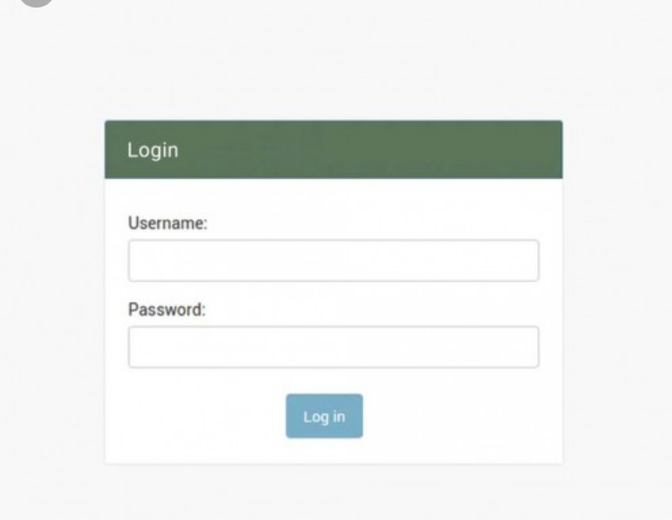

**Figure 3.3.2.2** [**Https://www.google.com/search?q=a+picture+of+login+module&client=ms-opera-mini-android&channel=new&source=Inms&tbm=Isch&sa=X&ved=0ahUKEwilmozAIIj0AhUKnnxQKHRDoDEsQ_AUIB&biw=424&bih=730#imgrc=rvddILRcCb9PNM**](Https://www.google.com/search?q=a+picture+of+login+module&client=ms-opera-mini-android&channel=new&source=Inms&tbm=Isch&sa=X&ved=0ahUKEwilmozAIIj0AhUKnnxQKHRDoDEsQ_AUIB&biw=424&bih=730#imgrc=rvddILRcCb9PNM)

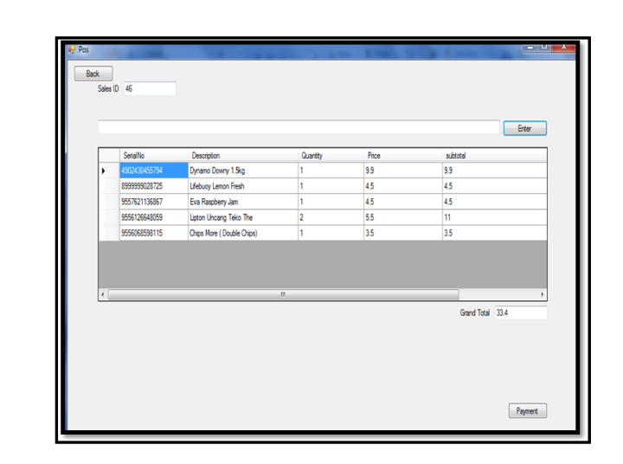

Figure point of sale page

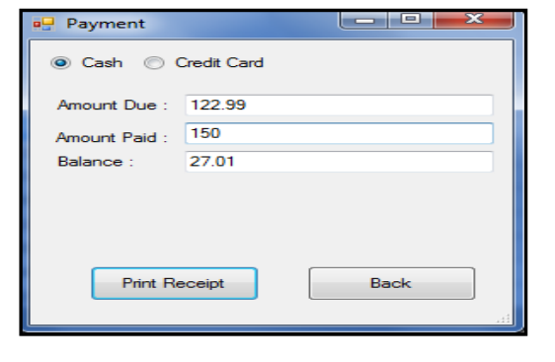

Figure payment page

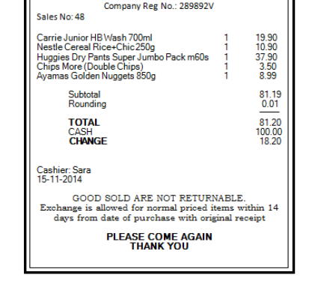

Figure customer receipt

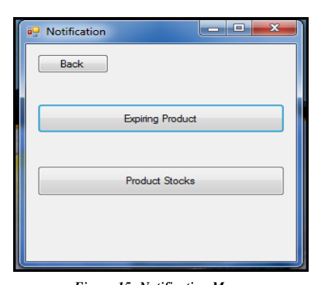

Figure notification menu

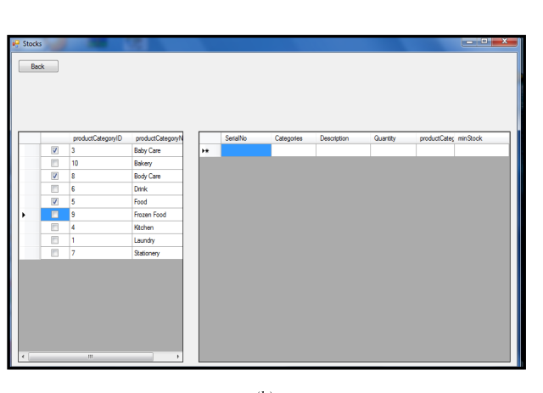

Figure notification page

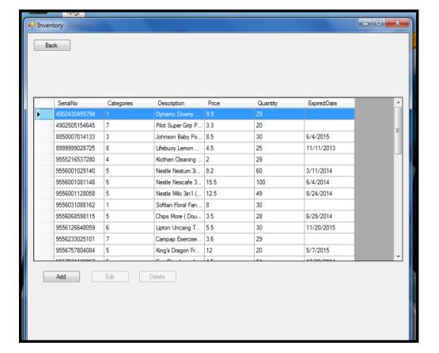

Figure Inventory page

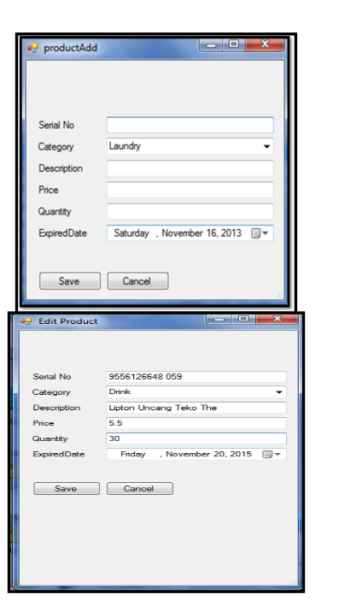

Figure product/edit page

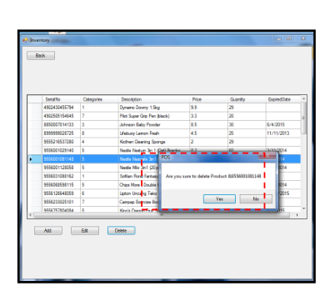

Figure confirmation message

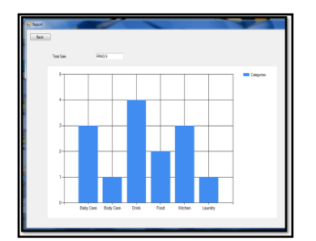

Figure report page

**System testing**

system testing was divided into three parts: developer testing, user testing and customer testing.

Developer testing, it’s the data entered by admin and staff is stored in Microsoft access database. Since the transaction involve a lot of database interactions,it is important to test the performance of database used.

User testing, testing is done after the development of the software is complete.

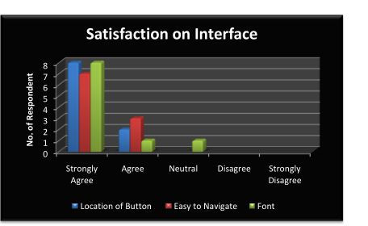

Figure satisfaction on interface

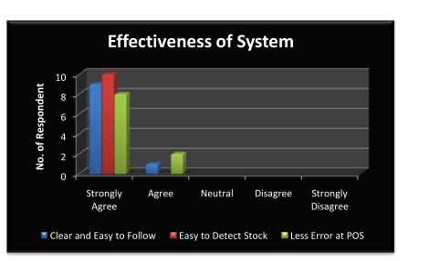

Figure Effectivenes of the system

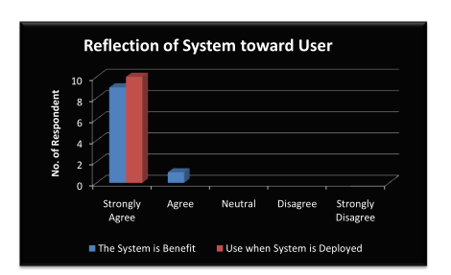

Figure reflection of the system towards user

Customer testing on customer testing is done to get feedback on the new application of sales system. Basically they are given set of feedback from on how they rate the performance and speed of processing the transaction at the counter using the system.

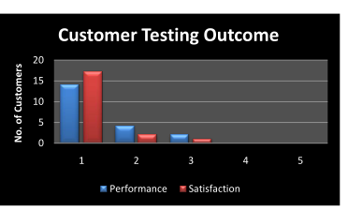

Figure customer testing outcome

**3.3 Implementation/Coding/Development**

I intend to develop the system using php for backend development, HTML for front-end development and mysql for database. I will use notepad++ as my editor for writing my code.

**3.4 Testing**

I intend to do unit testing to measure if my module work right, integration testing to ensure all my modules can successfully pass data to one another and to the database. I will also conduct system testing to en sure that the system works as was designed in low-level design. I prefer to do cross-platform compatibility testing to see whether the system will run on different operating system

**3.5 Deployment**

I intend to use bare metal deployment technique where am going to create an executable file for my system and run it on my laptop or any other window based workshop machine.

**3.6 Maintenance**

I do not intend to do any scheduled maintenance for my system since its being represented for demo. However I will do corrective maintenance after panel presentation to give me an opportunity to keep working and bettering the system.

**CHAPTER FOUR: CONCLUSIONS AND RECOMMENDATIONS**

**4.1 conclusions**

It is clear that sales and inventory management for a baby products shop system can be a very powerful tool to manage to manage sales records for a shop. All the modules present play a very role in ensuring efficiency, integrity and timeliness in the sales and payment process. The proposed project will carry easy to use and user friendly tools, supported by powerful and accurate classes, objects, functions and overall code that will make data input, processing and output to occur as stipulated in design. The proposed system will also go through scrutiny by the project supervisor who will help implement the gray areas and will finally go through a panel presentation on the last phase.

**4.2 recommendations**

The objectives in this project test well when tested in Eastleigh according to my research. The system will work well when introduced and will improve both the profit and customer satisfaction. Finally, due to money and time constraints I was not able to do face to face research. Nevertheless the positive response is that ia online research the system may be able to be effectively used.

**CHAPTER FIVE: REFERENCES AND APPENDICES**

**5.1 REFERENCES**

1. Tim Crosby(2007) , How Inventory management systems Work Retrieved 2,Jan 2022 from <http://money.howstuffworks.com/how-inventory-management-systems-work1.htm>
2. Wikipedia(2022),inventory management software Retrieved 2 Jan 2022 from <http://en.wikipedia.org/wiki/inventory_management_software>
3. Anton Dolinsky (2022), Barcodes, sales and inventory retrieved 2 Jan 2022 from <http://www.almyta.com/Inventory_management_history_4.asp>

**5.2 Appendices**

**Appendix 1: Map**

Log in

payment

Calculate total sale

Transaction receipts

Scan item

Check out

Product catalogue

Update database

Update item

Print report

**Appendix2: Questionnaire**

1. **What is your name?**
2. **How long Eastleigh baby shop is in operation?**
3. **What is current level of recording inventory?**
4. **What is the current method used in carrying out customer sales?**
5. **What problems are faced by the store in managing inventory?**
6. **Did customer complain of the product that out of stock?**
7. **What if the customer wish to exchange the item purchased?**
8. **How you detect the expired products in the store?**
9. **Why never use any system in doing business?**
10. **Will you use system that will help you in managing the inventory**
11. **?**
12. **What are requirements in the system to be developed**

**Aappendix3: Gantt chart**

**P**

DEC 2021

PROJECT SATUS

Scan item,calculate total sale transaction receipt and payment

Scan item,calculate total sale transaction receipt and payment

TASK 3

ADMIN

STAFF

CUSTOMER

TASK 2

ADMIN

STAFF

CUSTOMER

Product catalogue and check out

Update item, update database and print report

Log in and check out

Payment and check out

TASK 1

ADMIN

STAFF

CUSTOMER